JOB APPLICATION TRACKING SYSYTEM

1.INTRODUCTION

An applicant tracking system is software for recruiter and employers to track candidates throughout the recruiting and the hiring process.

1.1 OVERVIEW

*Candidate relationship management

*Managing interviews

*Candidate sourcing

1.2 PURPOSE

* An ATS create opportunities to automate manual processes ,increase visibility into the hearing cycle for the entire recruiter team .

* Recruiting using ATS reports that it has improved the quality of the candidate they here.

PROBLEM DEFINITION & DESIGN THINKING

2.1 EMPATHY MAP

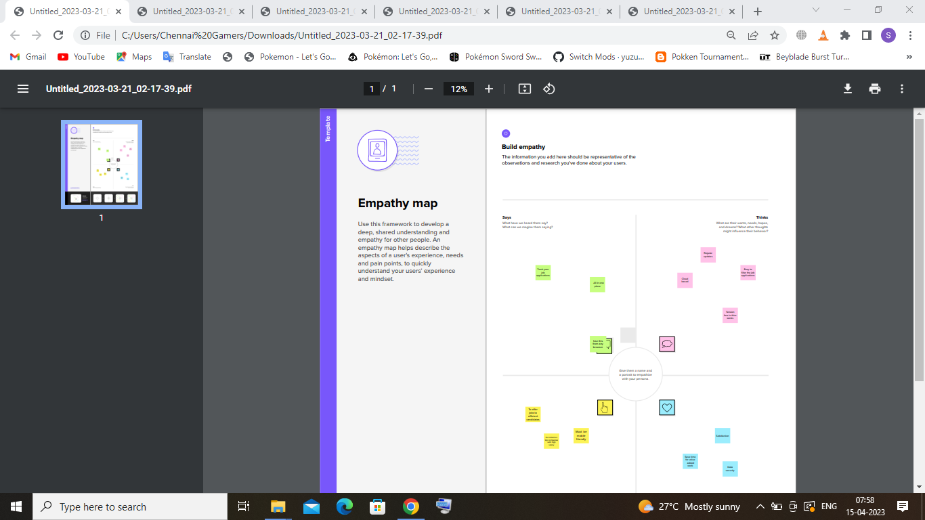

2.2 IDEATION & BRAIN STROMING MAP

#### 

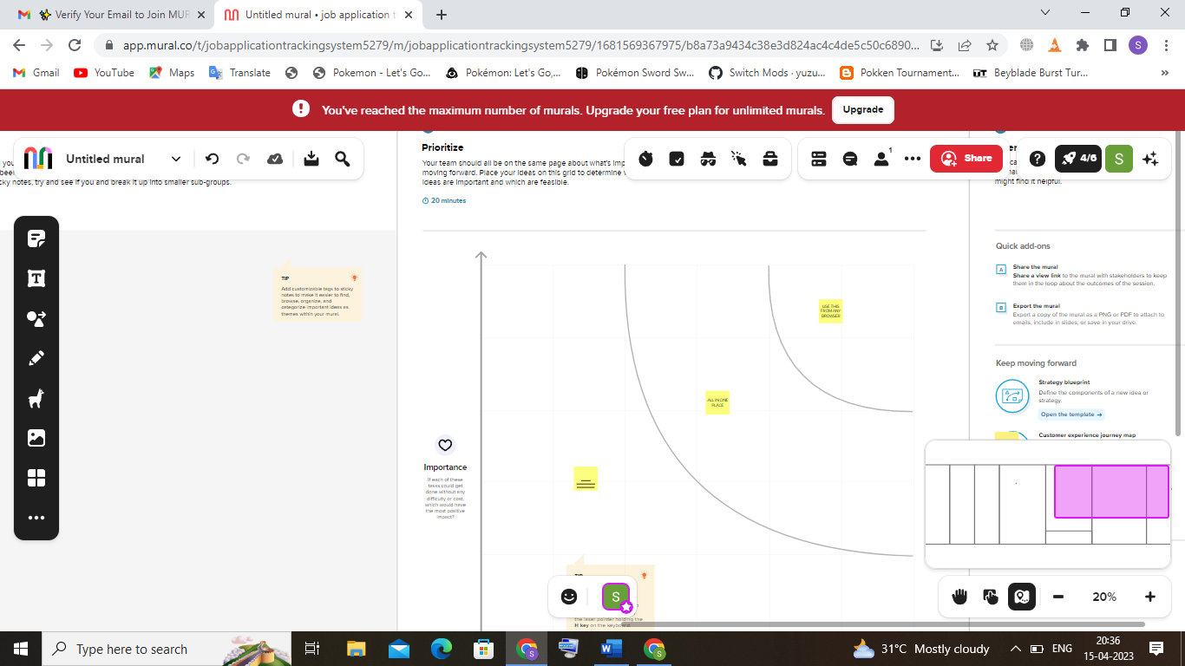

**3.RESULT**

3.1 DATA MODEL

|  |  |
| --- | --- |
| OBJECT NAME | FIELDS IN THE OBJECT |
| Object 1 | |  |  | | --- | --- | | Field lable | Data Type | |  |  | |  |  | |
| Object 2 | |  |  | | --- | --- | | Field lable | Data Type | |  |  | |  |  | |

3.2 ACTIVITY & SCREENSHOT

Milestone 1:

Go to developers .salesforce.com/click on signup .on the signup form enter the details .After signing up ,go to your inbox of mail and activate your account and click on the verify account..After the verification again go to salesforce.com and login , then enter the user name and password that you have created .After login homepage which you will see.

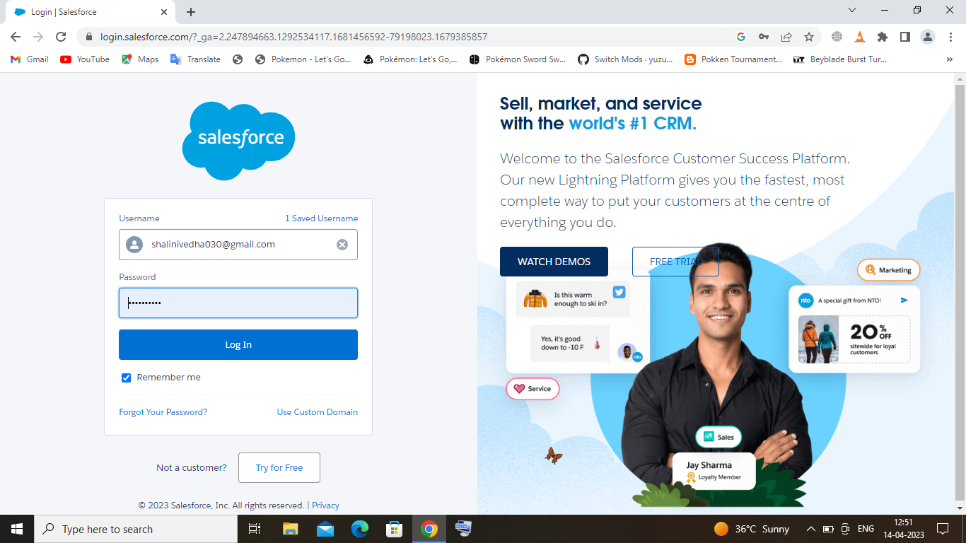

Milestone 2:

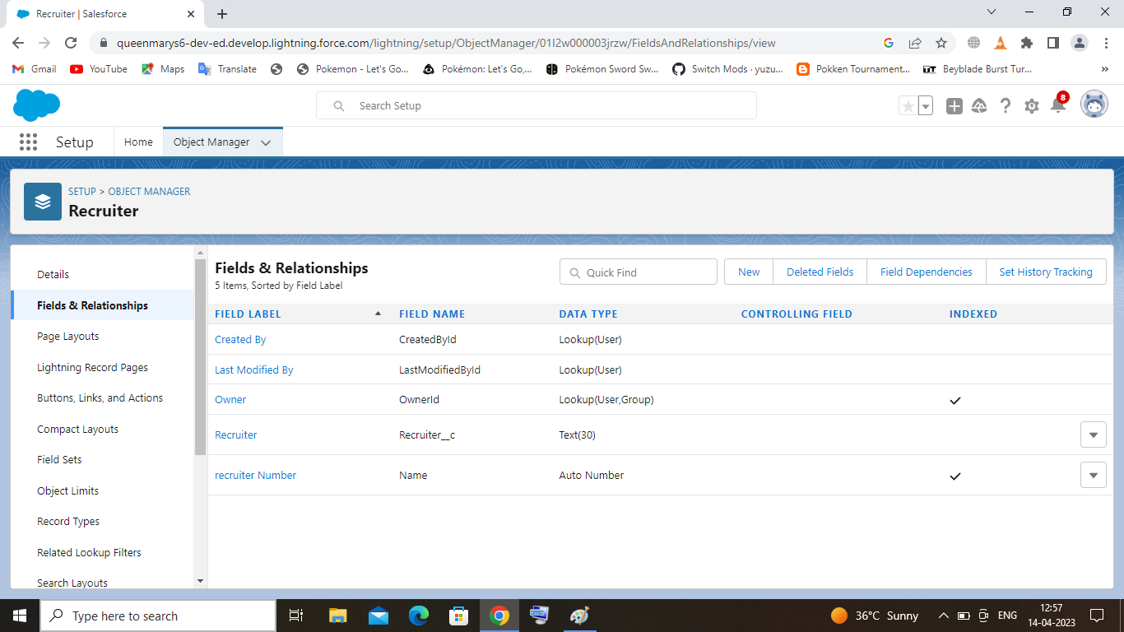

Milestone 3:

Milestone 4:

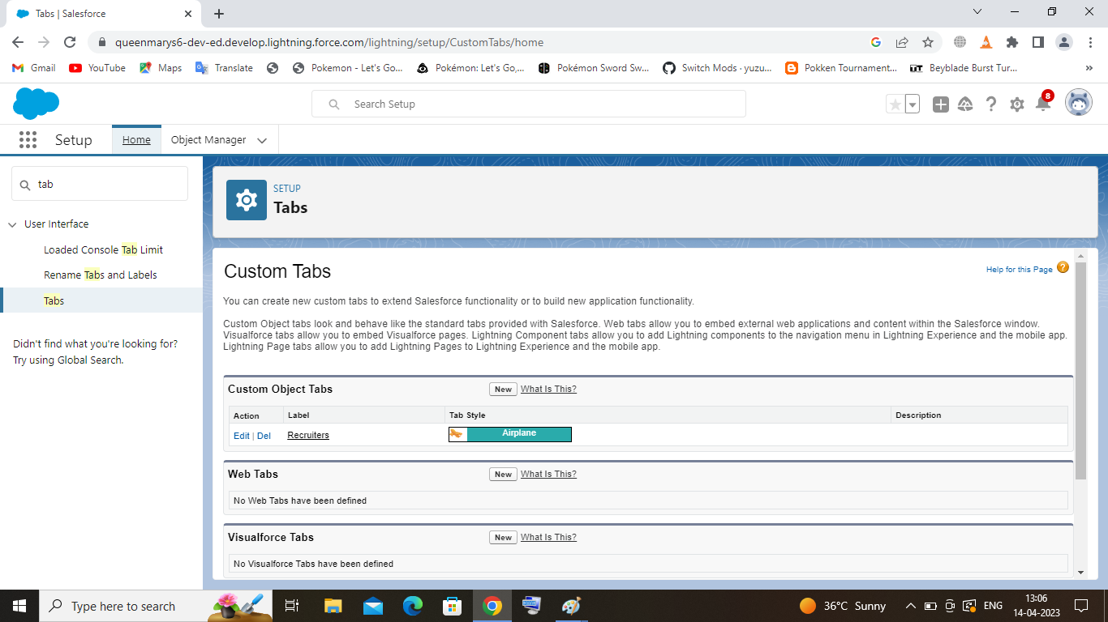

Milestone 5:

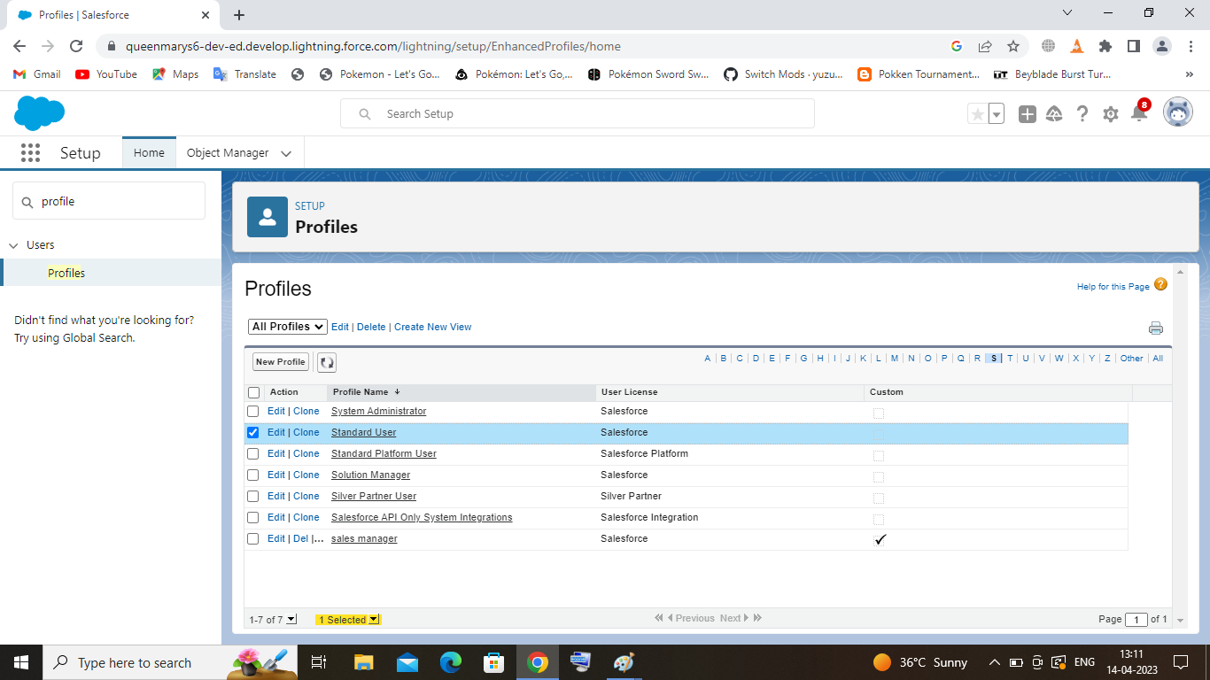

Milestone 6:

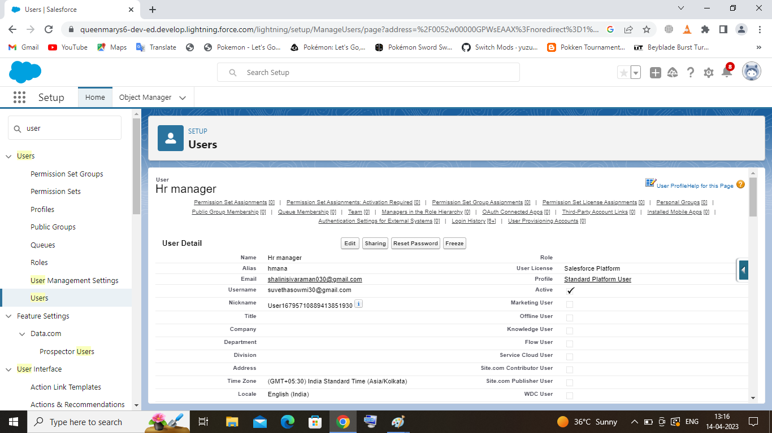

Milestone 7:

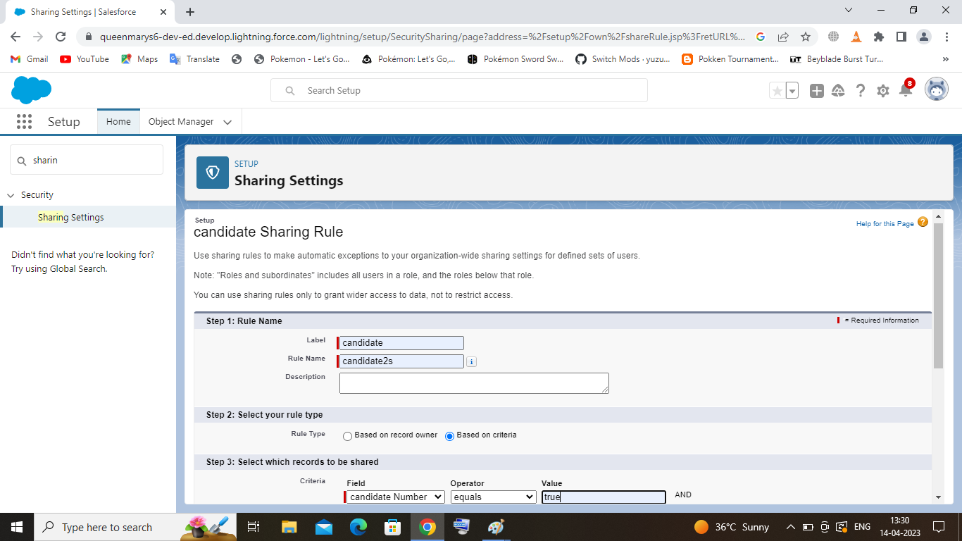

Milestone 8:

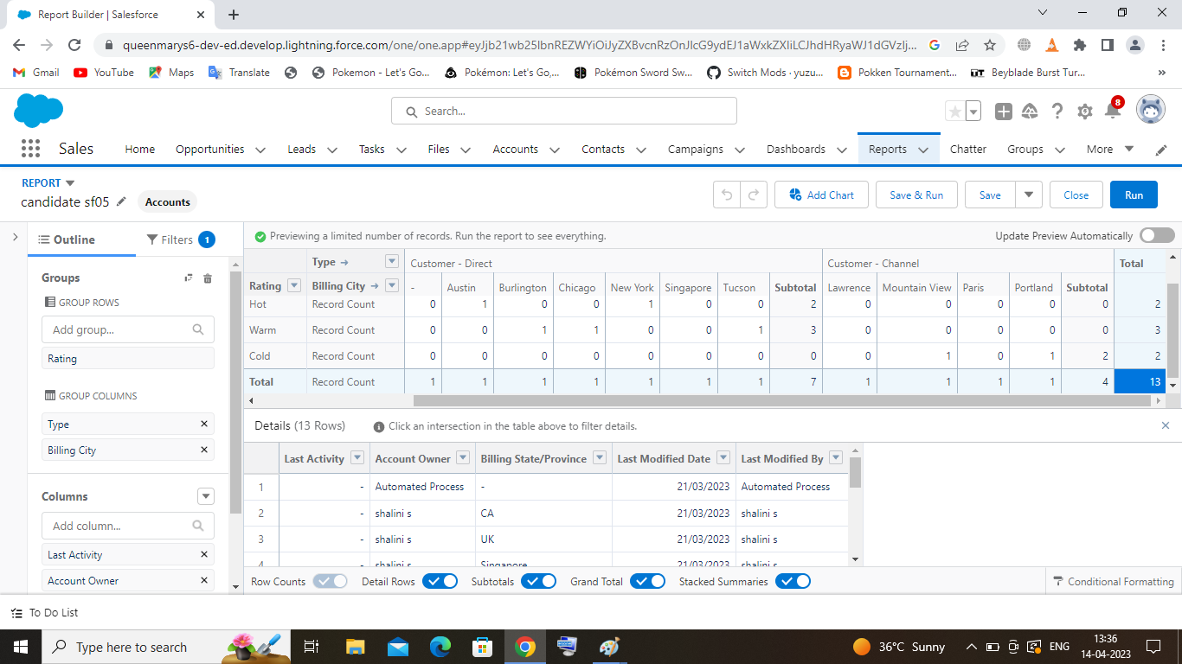

4 .TRAILHEAD PROFILE PUBLIC URL :

Team Leader- https://trailblazer.me/id/shals53

Team Member 1- https://trailblazer.me/id/swatb12

Team Member 2- https://trailblazer.me/id/vedhd4

Team Member 3- https:// trailblazer.me/id/sowmr19

Team Member 4- https://trailblazer.me/id/suvea1

5.ADVANTAGES & DISADVANTAGES

* Advantages

Builds your brand

Post job on multiple job both

Manages talents database

Growing business offer and end of recruiter for multiple position at the same time.

* Disadvantages

Qualify applicant due to wrong keyboard selection

Automated elimination of resume that software cannot recognize and interrupt is another ATS

6.APPLICATIONS:

GPS tracking

Float management

Person tracking

Distribution and Manufacturing

Yard management

7.CONCLUSION

ATS for recruiters is a very effective hearing solution that most of the successful recruiter utilize. There is good chance that yours processes of moving applicants through different become very difficult.

8.FUTURE SCOPE:

The majority of staffing forms world wide will option for applicant tracking system by the end of 2020 improve the overall talent acquiresation talent efficiency in this scope the future of applicant tracking system definitely looks right.